**[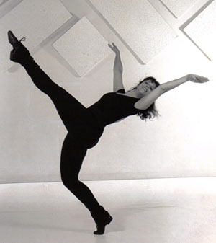](http://www.jazzandroots.com/wp-content/uploads/2009/06/jazz_dance.jpg)Where Has Jazz Dance Come from?**

Battements. Turns. Leaps. Isolations. The trademarks of classical jazz dance are easy to recognize, but do you know where these moves actually came from?

Jazz came into its own as a style after World War I, but the foundations of jazz dance and music go back much further into American history. Africans that were brought to North America as slaves fused their traditions with the European, South American and Asian traditions to form jazz. Like tap, jazz is an American creation, but because it keeps changing, it's hard to define. So how did jazz become the artform it is today?

**1740:** The U.S. government passes a law prohibiting "beating drums and blowing horns." African-born slaves turn to their bodies as instruments, incorporating the same percussive rhythms.

**1830s-1890s:** The rise of the minstrel show, the first professional performing outlet for African Americans. Two distinct circuits evolve, segregating white and black performers. Both races perform in blackface, presenting numbers like the cakewalk that had evolved from plantation dances. The most celebrated performer of the 1840s is a freeborn black named Master Juba. He dances with different rhythms in different parts of his body. This style becomes the foundation of jazz and tap dance. His moves will spawn jazz's isolations and syncopation.

**1918-1929:** In the Jazz Age, people embrace highly syncopated music and dance, celebrating musicians' ability to improvise and dancers' ability to express their individuality.

**1944-1948:** Jack Cole, considered the father of theatrical jazz dance, develops "The Dance Workshop," a group of highly trained ballet, modern and acrobatic dancers that perform in L.A. nightclubs and theaters. Cole's study of Indian classical dance, Bharatanatyam, with its isolations and quick directional changes, influences his style.

**1945:** Katherine Dunham opens the Dunham School of Dance and Theater in NYC. Her dancer Syvilla Fort teaches shoulder, rib, hip and pelvis isolations while crossing the floor. These moves will become standard practice in jazz classes.

**1950s:** Studios begin offering classes similar to what will become jazz class: Freestyle (fast-moving, ballet-based technique), Musical Comedy (a style devoted to humorous movement), Primitive (any style that wasn't ballet, tap or social dance) and Afro-Caribbean.

**1955:** In Manhattan, Luigi and Matt Mattox begin teaching in the tradition of Jack Cole, emphasizing ballet's elongated lines and tap's rhythmic complexity. Their class includes a warm up, across-the-floor sequences and a culminating combination. **The modern-day jazz class is born.**

**1955-1957:** Jerome Robbins conceives, choreographs and directs West Side Story. Robbins' edgy, graceful and athletic movement fuels jazz dance's popularity.

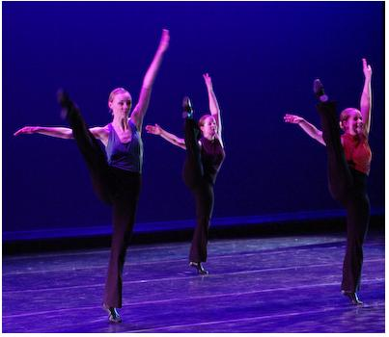**1980s:** Rise of music videos in which jazz dance's overt sexuality finds mass appeal. For pop stars like Paula Abdul and Madonna, dance ability becomes as important as musical talent. On the concert stage, choreographers are bringing jazz moves to audiences

accustomed to ballet and modern dance.

**2000 AND BEYOND:** Jazz is everywhere, from "So You Think You Can Dance" to the competition/convention circuit, and has merged with hip hop, ballet, modern, world dance and more.

Straus, Rachel. “And All That Jazz”. *Dance Spirit* January 2008: p 80-82.

In your FAS notebook, answer the questions below.

1. What country did jazz dance originate?
2. What culture inspired jazz dance?
3. Name four common steps or movements found in a jazz dance class.
4. What musical popularized jazz dance in our country?
5. What is the order of a jazz dance class?